ADVANCED MEDICAL SUPPLY, INC.
3322 N Milwaukee avenue, Chicago, IL 60641
Phone: 773-205-6993 Fax: 773-205-6994
PATIENT NAME: YVONNE MCLAURIN (F)
INSURANCE ID#: XOG911788057 DOB: 02/28/1968
ADDRESS: 4727 N MALDEN ST UNIT114 CHICAGO, IL 60640
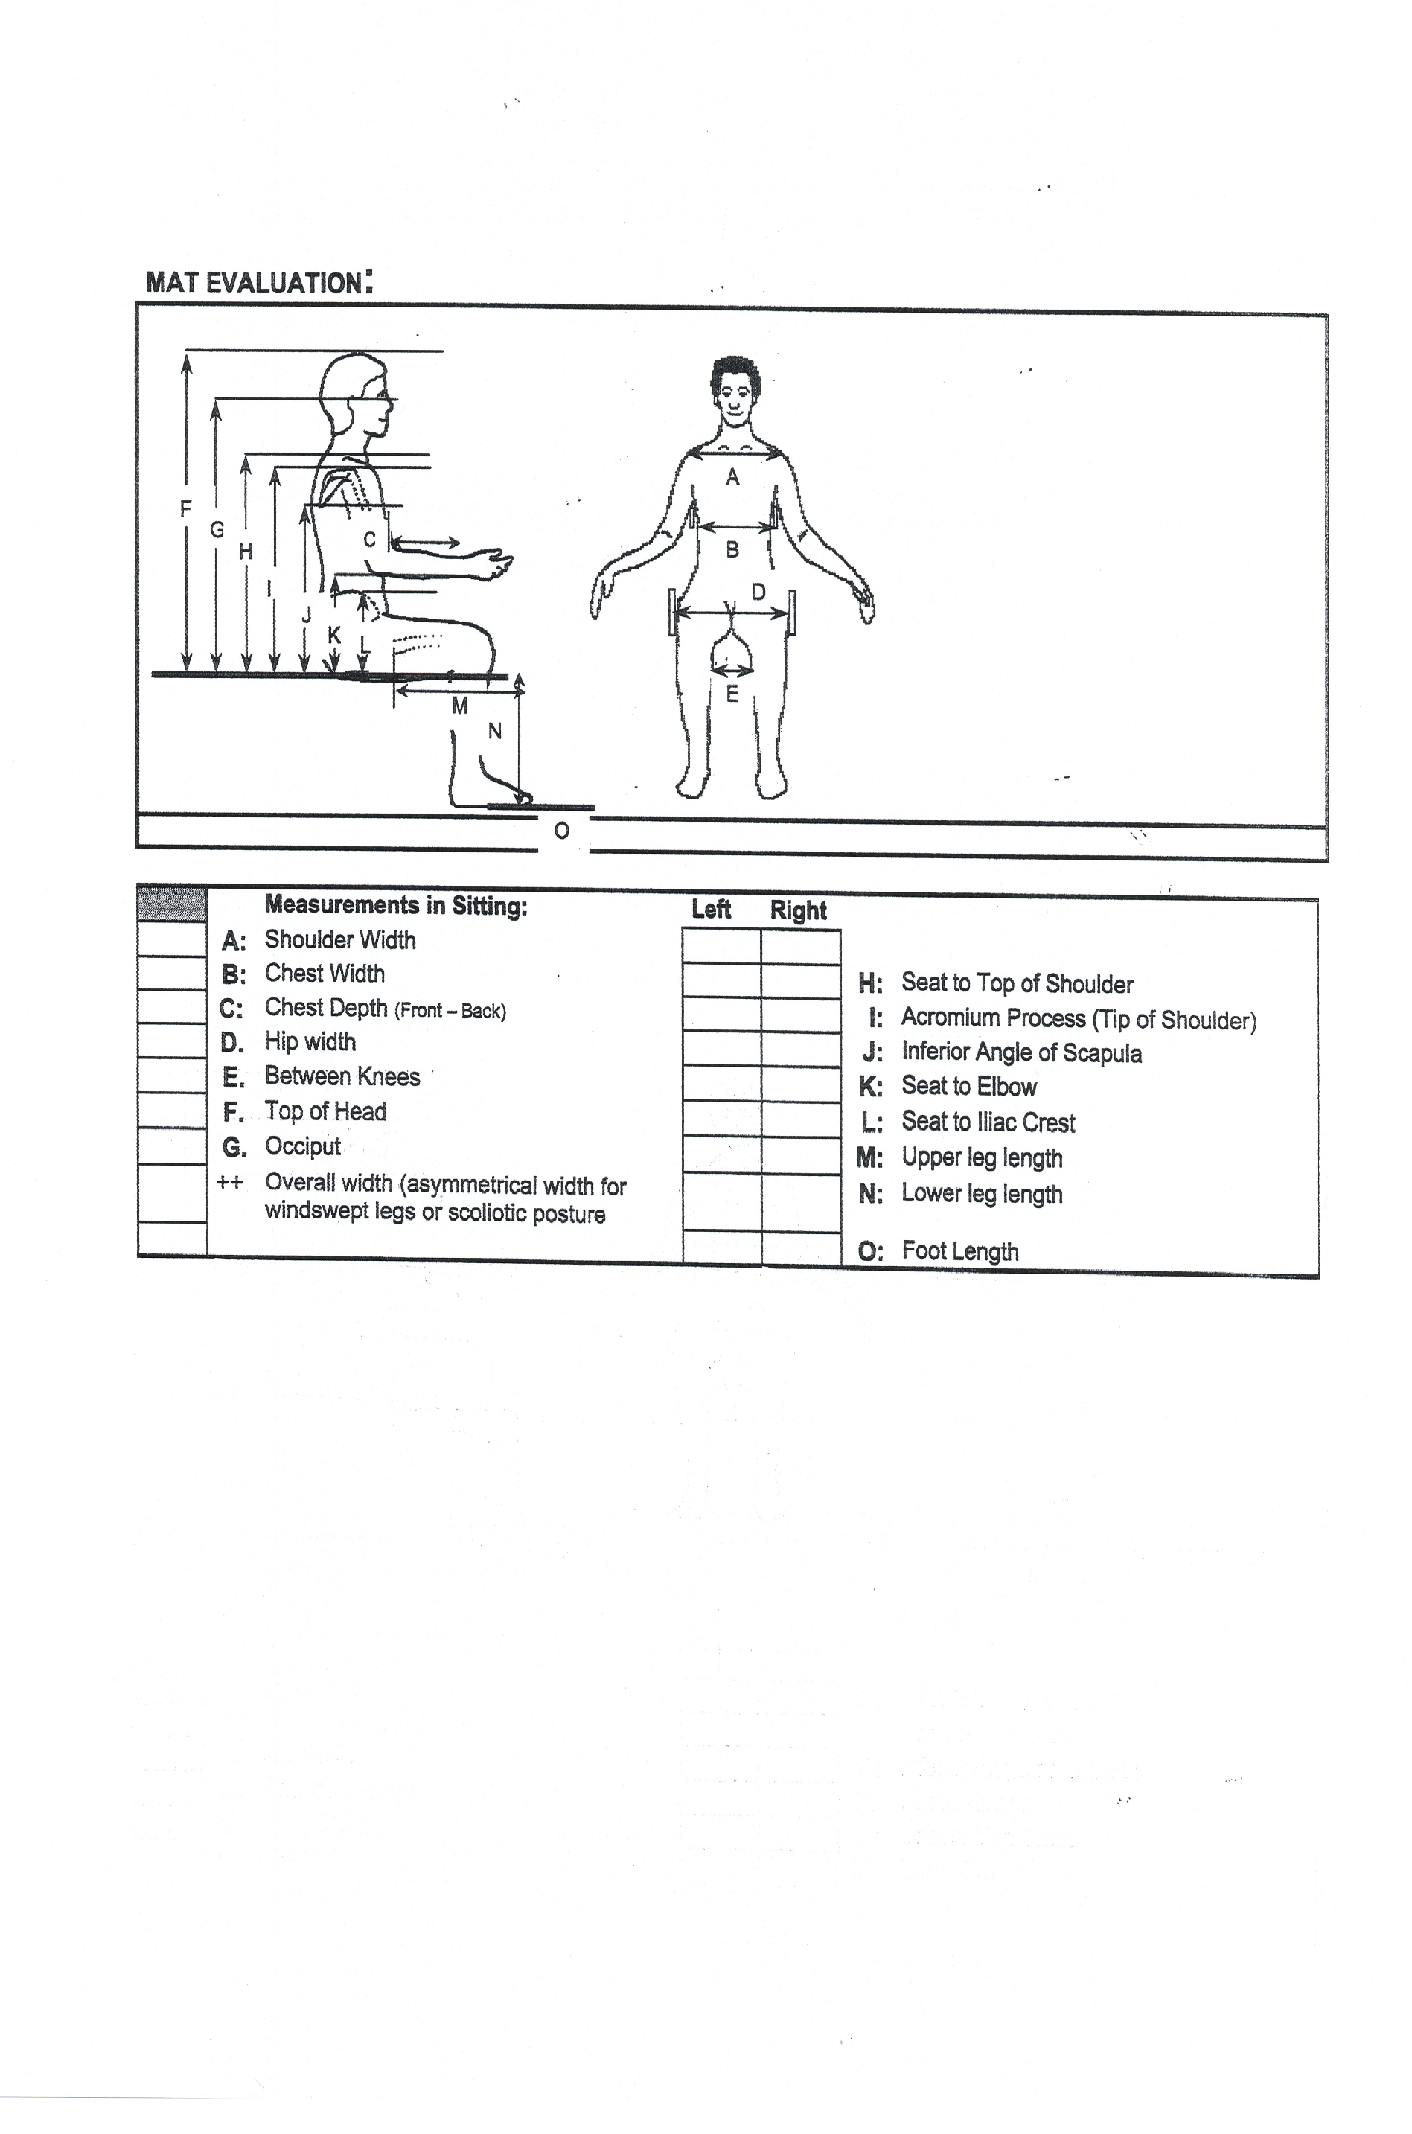
PHONE #: (872) 235-2014

Patient’s Signature:___________________________________________________________________ Date:________________
Signature if other than patient:___________________________________________ Relationship:_________________________
Name if other than patient:__________________________________________________________________________________
Reason patient is unable to sign:______________________________________________________________________________
Evaluator’s Signature:_________________________________________________________________ Date:________________
Evaluator’s Name (printed):_________________________________________________________________________________

